Lab Exercise 1- Working with Git Revert
Lab Exercise: Git Revert
This exercise will guide you through reverting changes in Git. The git revert command is used to create a new commit that undoes the changes introduced by a previous commit without modifying the history.

Objective
- Learn how to use git revert to undo changes from specific commits.
- Practice handling merge conflicts during a revert.

Prerequisites
- Install Git on your system.
- Set up a Git repository:
git init git-revert-lab
cd git-revert-lab
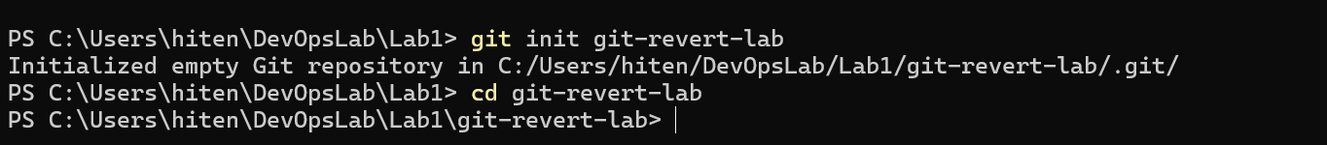

Steps
1. Set Up the Repository
- Create a file:
echo "Line 1" > file.txt
- Stage and commit the file:
git add file.txt
git commit -m "Initial commit: Add file.txt with Line 1"
- Add more changes:
echo "Line 2" >> file.txt
git commit -am "Add Line 2 to file.txt"
- Add another change:
echo "Line 3" >> file.txt
git commit -am "Add Line 3 to file.txt"
- Verify the commit history:
git log –oneline
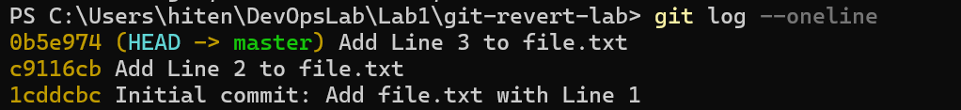

Example output:
c3f6b6b (HEAD -> main) Add Line 3 to file.txt
8b2a1c1 Add Line 2 to file.txt
4d5f8e9 Initial commit: Add file.txt with Line 1

2. Revert the Last Commit
- Revert the most recent commit:
git revert HEAD
- Git will open a text editor for the commit message. Save and close the editor to complete the revert.
- Verify the contents of file.txt:
cat file.txt
Output:
Line 1
Line 2

- Check the commit history:
git log –oneline
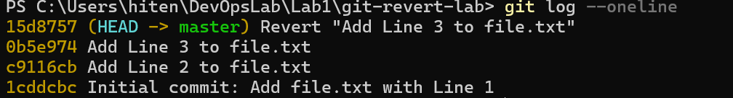
Example output:
e5d2f8a Revert "Add Line 3 to file.txt"
c3f6b6b Add Line 3 to file.txt
8b2a1c1 Add Line 2 to file.txt
4d5f8e9 Initial commit: Add file.txt with Line 1

3. Handle Merge Conflicts During Revert
- Modify file.txt:
echo "Conflict Line" >> file.txt
git commit -am "Add Conflict Line"
- Revert the second commit (8b2a1c1 again) to trigger a conflict:
git revert 8b2a1c1
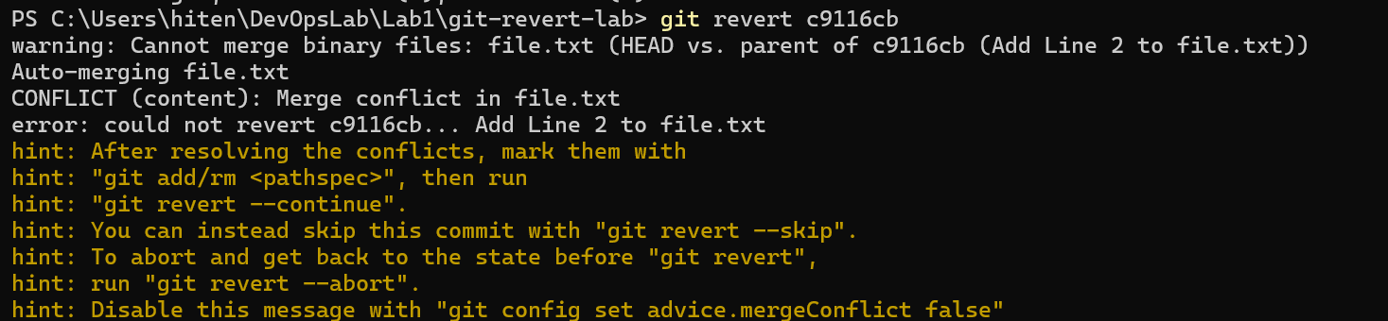
- Git will indicate a conflict. Resolve it:
  - Open file.txt and remove conflict markers.
  - Keep the desired lines.
- Stage the resolved file:
git add file.txt
- Complete the revert:
git revert –continue

